Bulk Registration Feature – Functional Spec
  - Phase 1

Contents
Overview 2
High Level Workflow 2
Feature Locations 2
Security 3
Logging 3
Claimed Purchases Page 3
Claim Additional Purchases 3
Review Current Claims 4
Bulk Activation Page 5
Select Devices 5
Default Asset Values 6
Select Available Licenses 6
Apply Licenses 6
Customize Page 8
Review Page 10
Bulk Activation History 11
DB Changes 12
Bulk Registration Background Process 13
Test Data 13
Future Phases 14
Questions 14

Overview
This feature is intended to ease the process of registering and/or licensing many devices. Currently device registration can only be done one at a time. Similarly license activation is also one at a time, per device, and can’t be done at the same time as device registration (it can be done immediately after, though).

The Bulk Registration feature should provide an easy way for users to specify multiple devices and licenses to register/activate, customize their choices and finally review them in a way likely to catch most errors before submitting the bulk request. The request should process in the background and provide way(s) for the user to check on the status.

Rolling back bulk registrations is currently out of scope; however, we must record enough information that we could manually roll back the requests and eventually write an automated method of rolling back bulk registrations/activations as part of a possible “phase 2”.

High Level Workflow
Bulk registration is a multi-step process that users will walk through in a “Wizard”-type interface that presents each step in order while allowing users to save their progress or go back a step if they missed anything.
- Claim Purchases (Assets/Licenses)
- Select Devices/Licenses to use in Bulk Registration
- Customize your bulk registration job
- Review job and start the process
- Process runs in background, sending a notification of final status
- View Job history/status

Feature Locations
- There will be a “Claimed Assets” subtab under the Assets tab to the right of search all
- There will be a Bulk Activation History page available from a link in the goto menu (or possibly from the Claimed Assets page

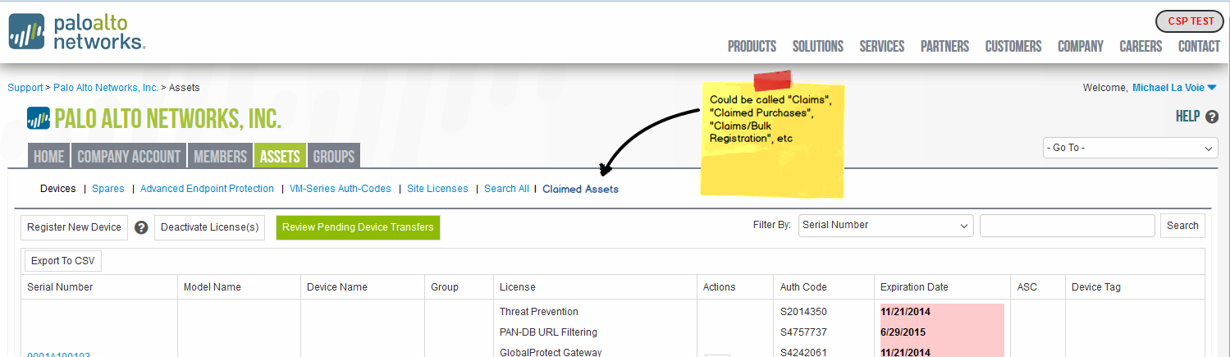

Security
All Bulk Registration features will be hidden by default and will only be visible/available to Super Users if the account’s “Allow Bulk Registration” rule is selected. Additionally for this phase of the project the Allow Bulk Registration rule will only be available to specific, named “Beta Access” accounts. These accounts may or may not be the same as the Nagoya Beta Access users/accounts and will be specified at a future date.
- Make this an account level feature (like super user approval) where the SU turns it on to enable it at the account level for all super users - no role
- Create “Allow Bulk Registration” checkbox on Company tab and on supportaccounts table
  - If checked allow bulk registration for any Super Users
- Restrict option to accounts with Beta Access to this feature. Other accounts won’t see the checkbox, and if the beta access is removed, customers should lose the option even if it was already selected
- TODO – Identify who will be responsible for finding our beta access candidates.

Logging
All actions tied to bulk registration must be permanently logged. Both so we know what happened, but also so we know who did it. Impersonations must log both the actual user and the user being impersonated. Regardless of how many super users have access to bulk registration, it can only be done by one person (two people can’t both work on the same bulk registration).

Logged Bulk Registrations should have enough detail to fully re-create the request and to roll it back; however, rolling back bulk registrations won’t be a requirement of this phase

Claimed Purchases Page
The Claimed Purchases Page has 2 sections: Claim Additional Purchases and Review Current Claims.

Claim Additional Purchases
- Users will enter 2 factors to identify an SAP purchase: Customer Code and Device Code (just like self-service registration).
- If they correlate using the same logic as self-service registration we will return a list of “Available Purchases”
- Available Purchases List
  - Will only show eligible purchases for this feature
    - Physical Devices of any type
    - VMs (VM-Series Auth Code? Where do we get CPU ID and UU ID?)
    - Non-site licenses
    - Register-able Part Types: DEV, SUP, RENSUP, SUB, RENSUB, RENACC
      - Not Allowed: SPARE, SITE, RENSITE, SER, CRED
      - Unsure: BUN, RENBUN *I Believe we will allow these, but need clarification for how they are handled differently than other devices
  - Will not show devices/licenses that are already registered/activated
  - If the current user is a member of an ASC and the claimed order was to a customer w/ an ASC license pointing to them (Same rules for ASC cross account registration)
    - Also show who the sales order was sold to (to help ASCs remember which order they’re looking at) call the column “End User/Customer”
- Users can move any number of purchases to the “Selected” grid before clicking the “Claim” button to add them to the claimed purchases table
- Both Grids must be sortable and filterable

Review Current Claims

- Claimed purchases can be unclaimed individually or in bulk
  - Unclaiming will be logged for record keeping
- Users can proceed to bulk activation from here
- Because the site currently supports single device registration and single license activation any claimed purchase could be manually registered/activated at any time
  - When loading the review claims grid we much verify that they are still unregistered/unactivated and remove any registered/activated purchases automatically

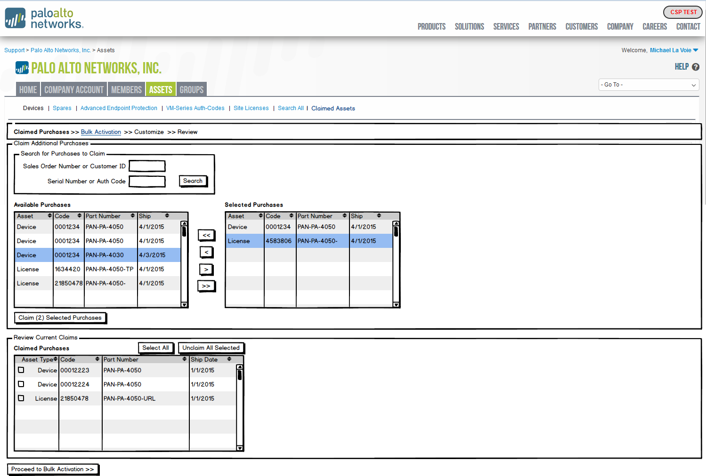

Bulk Activation Page
The goal of this page is to allow users to specify the claimed devices (and possibly vm-series) they want to register along with licenses they want to apply. Alternatively users can also specify already registered devices that they want to add new licenses to.

- Because the site currently supports single device registration and single license activation any claimed purchase could be manually registered/activated at any time
  - When loading the bulk activation page we much verify that all claimed purchases are still unregistered/unactivated and remove any registered/activated purchases automatically

Select Devices
- Will filter to either show claimed devices for this account (Regardless of who claimed them) or already registered assets that don’t already have every license
- You will only be allowed to select multiple devices that share “model compatibility” which determines which licenses can be applied.
  - Only one set of model compatible devices can be bulk registered/licensed at a time
- NOTE Site licenses cannot be used here (will update image soon)
- Clicking “Claim more purchases” at this time will save the bulk registration request as a draft (limit one draft per user) and return you to the previous “Claim Purchases” page

Default Asset Values
- These values will be used to initially fill in required fields on all devices that are registered.
- If a device is already registered and just getting new licenses, then these values will not be used.
- Fields include: Device Name, Tag, Address, Remarks
- These fields are optional at this stage if the user unchecks “Apply these default values” however; they are all required fields in the next step, Customize, so if users skip this step they will be prompted to enter values one at a time for all devices on the next page.
- Users can return to this page from the customize page to use this feature; however, only claimed devices that don’t yet have custom values will receive these default values to prevent overwriting hand populated values mistakenly

Select Available Licenses
- Will only display model compatible claimed licenses for the selected device type
- Show licenses grouped by sales order, than by type and show a quantity count
- When applied, the site will attempt to apply as many of that license grouping as possible in a FIFO (First In First Out) fashion meaning it will apply the oldest licenses to the oldest devices by ship date.

Apply Licenses
- Shows a grid with all selected devices listed down the first column and all applicable licenses grouped by type across the remaining columns
- Will support drag and drop re-assignment of licenses
  - More advanced license customization will be possible on the Customize page
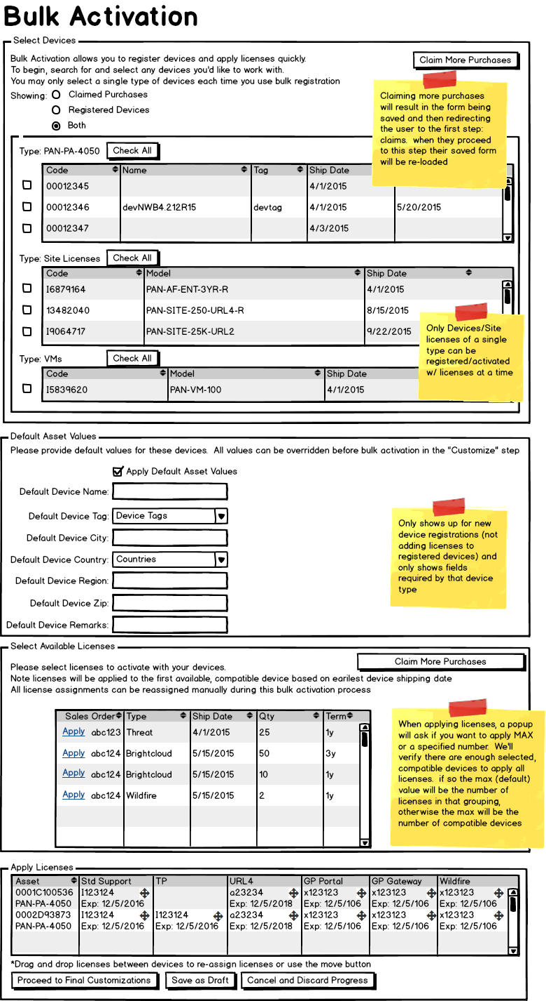

Customize Page
This page allows for final, detailed customization of all registration/activation details.
- We will list a group box for each asset being worked with
  - Each box will include the device custom values
    - If the device is already registered, we will pre-populate it with the existing values
    - If the device is unregistered we will populate with the default custom values, if provided
    - Any required fields will still be enforced here – this is especially important if the user didn’t provide default custom values
  - The licenses grid will show all new licenses being applied to the device
    - For existing devices, no existing licenses are shown here *Is this correct?
    - The move button will launch the move popup which will provide search functionality to make moving licenses on larger orders more convenient than drag and drop
  - Move Popup
    - Will allow full sorting/filtering of assets to make finding the destination asset easier
    - If the destination asset already has a license of the same type waiting to be applied than the user will have 3 options: Swap licenses, remove the destination license or cancel
- Because the site currently supports single device registration and single license activation any claimed purchase could be manually registered/activated at any time
  - When loading the customize page we much verify that all claimed purchases are still unregistered/unactivated and remove any registered/activated purchases automatically

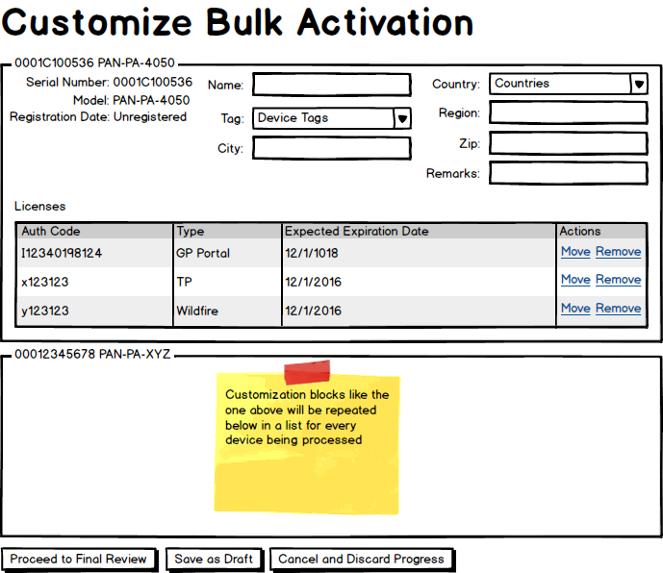

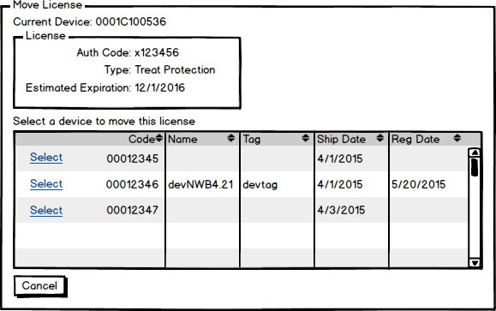

Review Page

- This page will contain exactly the same content as the customize page, but in a read only view
- Here we can provide final warnings/colorize fields to draw attention to them
  - What conditions should we check for, if any?
  - I believe we discussed showing any licenses that would be “already expired” if applied
- We will display the terms of service agreement as required on any registration/activation page
- Before finalizing the request we will put a confirmation popup as the final warning that says: “Please review your request one last time as bulk registrations cannot be undone! By Proceeding you agree to our terms of service and confirm that you understand this process is not reversible: Confirm or Cancel”
- This page will also be used when reviewing already submitted requests
  - The submit buttons and license agreement will not be shown in this case
  - A status will be shown at the top to indicate: when the request was submitted, who submitted the request, the status of the request (in progress, success, failure)
- Because the site currently supports single device registration and single license activation any claimed purchase could be manually registered/activated at any time
  - When loading the review page we much verify that all claimed purchases are still unregistered/unactivated and remove any registered/activated purchases automatically

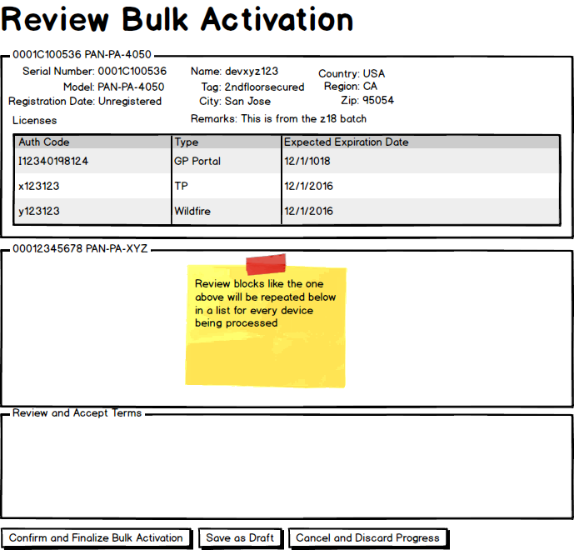

Bulk Activation History
The bulk activation history page will show all bulk activation requests that were submitted for the account regardless of who submitted it. By Clicking the View link the user will be taken to a read-only version of the Review Page to see specific details of the request.
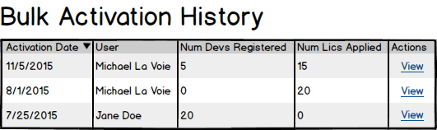

DB Changes
Claimed Purchases Table
- SupportAccountId
- DeviceId (allow nulls)
- LicenseId (allow nulls)
- CreatedBy
- ImpersonatedBy
- CreatedOn
- IsUnclaimed
- UnclaimedBy
- UnclaimedOn
Bulk Registrations Table
- SupportAccountId
- CreatedBy
- ImpersonatedBy
- CreatedOn
- IsSubmitted
- SubmittedOn
- State (Draft, Discarded, Pending, Success, Failure)
Bulk Registration Devices Table
- BulkRegistrationId
- DeviceId
- SerialNumber (in case the device is ever RMA’d)
- VmSeriesLicenseId (in case we’re registering VMs)
- IsAlreadyRegistered
- CustomValueDeviceName
- CustomValueDeviceTagId
- CustomValueCity
- CustomValueCountry
- CustomValueRegion
- CustomValueRegionId
- CustomValuePostalCode
- CustomValueRemarks
- CreatedOn
- IsRegistrationSuccessful
- RegistrationNotes
- RegisteredOn
Bulk Registration Licenses Table
- BulkRegistrationDeviceId
- LicenseId
- CreatedOn
- IsActivationSuccessful
- ActivationNotes
- ActivatedOn

Bulk Registration Background Process
The CSP UI will be responsible for preparing Bulk Registration requests; however, we will have a separate background process that actually executes the requests and communicates the status to the DB and possibly directly to the user’s email address – if they select that option.
Processing logic will start by registering any unregistered devices, then by applying all licenses. If an error occurs, it will be logged per device/license and the rest of registration will continue. At the end of the whole process a single status email will be sent to the end user. If there are any errors than a status email will also go to IAD and TAC (who owns the error/response? Should TAC own, then contact IAD?)

Test Data
Testing this feature will require that we be able to create bulk fake purchases including devices and licenses (and possibly some ASC licenses) with SAP sales orders in the DB.
Single System Black Box Testing – We will need to create some scripts to help create fake sales orders and unregistered devices/licenses in CSP for initial testing.
Cross System Integration Testing – we should also do tests where realistic orders are placed through
Device Types/License Types – we should test every combination of device/license that are allowed to ensure our code responds appropriately to each scenario.
Error Testing – we should test a bulk registration error to ensure the response protocols are properly followed and to ensure that all teams TAC/IAD know how to respond

Future Phases
This document describes Phase 1 of the Bulk Registration feature. Future phases will likely include opening up this feature to a wider range of users, or all accounts of a certain type (possibly ASC), or even to all users.
Additionally, future phases may include automatically rolling back bulk registrations or even “partial rollbacks” where we roll back just the mistaken part of a bulk registration.
The Phase 1 Beta users will likely report back problems, suggestions and will describe new use-cases that may all result in new requirements.

Questions
- Who are the initial beta customers?
- Will VM Series be register-able here? Where will we get CPU ID and UU ID?
- On the customize/review page if the user is working with already registered devices should we show the existing licenses?
- Should we check for any conditions on the review page to help prevent errors by the user? Like highlighting assets that don’t have any licensing being applied? Or if we see nearly all assets have a license of type x, but a few don’t should we highlight those?
- If a bulk registration fails, completely or partially, should we notify an internal team? How should we respond to the customer?

